Ideation Phase
Define the Problem Statements

Date | 18 October, 2026
Team ID:
Project Name | IMovies – Movie Ticket Booking Made Simple
Maximum Marks | 2 Marks

Customer Problem Statement:
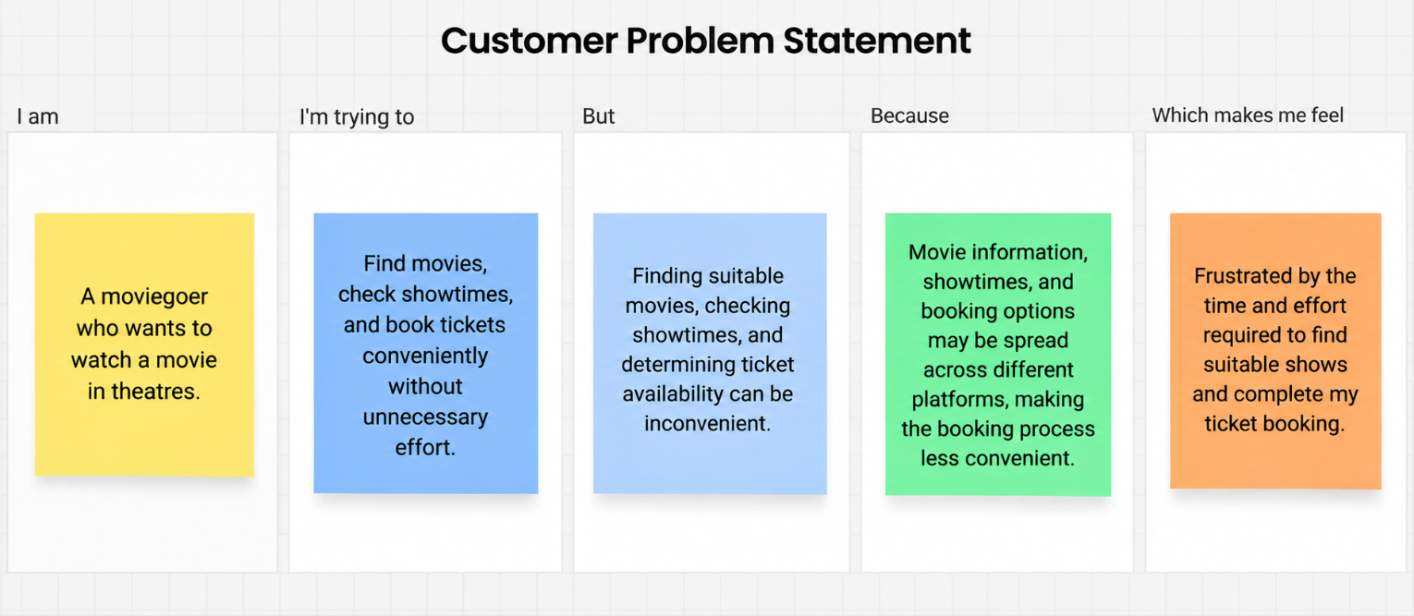
To identify and understand the key challenges moviegoers face when discovering movies, exploring available theatres and showtimes, checking ticket availability, and booking tickets online. By examining these challenges and understanding their underlying causes, this section aims to establish clear customer problem statements that will guide the development of IMovies, helping shape a more convenient, accessible, and user-friendly movie discovery and ticket-booking experience.

Problem Statement (PS) | I am (Customer) | I’m trying to | But | Because | Which makes me feel
PS - 1 | A moviegoer who wants to find a movie to watch. | Discover movies that match my interests, preferences, and viewing choices. | Finding relevant movies among the many available options can be difficult. | Movie information and discovery options may be spread across different platforms, making it harder to identify suitable movies. | Overwhelmed by the available choices and frustrated by the effort required to find a suitable movie.
PS - 2 | A moviegoer who wants to watch a movie at a convenient theatre and time. | Find theatres showing my preferred movie and compare available showtimes. | Identifying a suitable theatre and showtime that fit my schedule can be inconvenient. | Theatre locations, showtimes, and ticket availability may require checking multiple sources. | Frustrated by the time and effort needed to find a suitable show.
PS - 3 | A moviegoer who wants to book tickets for a selected movie. | Complete my ticket booking through a convenient and straightforward process. | Completing a booking may involve navigating multiple steps or platforms. | Booking options, seat availability, and ticketing processes may vary across platforms and theatres. | Frustrated when the booking process takes more time and effort than expected.

